# **Zabbix MYSQL Query to generate Alert history report**

The below illustration shows the tables we will be using and the nature of the joins

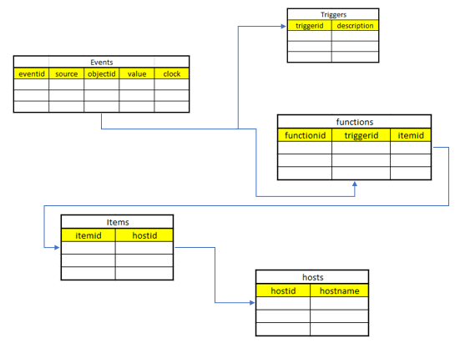

Below is the mysql query used

> select DISTINCT(events.eventid), CONVERT(from_unixtime(events.clock, "%Y-%m-%d %H:%i:%s"), DATETIME) AS Date_Time, triggers.description, hosts.host

FROM events, triggers, functions, items, hosts

WHERE

events.source=0 AND events.value=1 AND CONVERT(from_unixtime(events.clock, "%Y-%m-%d"), DATE) BETWEEN date('2018-07-01') AND date('2018-07-10') AND

events.objectid = triggers.triggerid AND

events.objectid = functions.triggerid AND

functions.itemid = items.itemid AND

items.hostid = hosts.hostid

ORDER BY Date_Time DESC

INTO OUTFILE '/var/lib/mysql-files/report.csv' FIELDS TERMINATED BY ',' ENCLOSED BY '"' LINES TERMINATED BY '\n';